Michael Harty,TD.
Chairman
Oireachtas Joint Select Committee on Health
6 September 2016

‘Cover’ letter in relation to the Submission sent, 5 Sept. 2016, by Connolly for Kids Hospital to the Oireachtas Committee on Health.

Dear Dr Harty
Connolly for Kids Hospital (C4KH) understands that the Committee on Health has an important oversight role in monitoring and ‘shadowing’ the actions of the Department of Health.
In this submission C4KH documents the false claims of suitability of the St James’s Hospital site as the location of the proposed new National Paediatric Hospital. This hospital is to be the central ‘hub’ of the National Model of Care for Paediatric Healthcare Services in Ireland. The lack of any evidence that there is clinical benefit to children of co-locating their hospital with St James’s is highlighted. And - we call attention to so much else that is wrong with the location (as was also true of the previous Mater site) which will limit the effective functioning of this essential national resource.
Two wrongs don’t make it right.
It is imperative that the Minister for Health and the Cabinet are made fully aware by your Committee that the responsibility for the location of the National Paediatric Hospital is theirs and theirs alone. Government, solely and unequivocally, is responsible for health policy- and for its outcomes. An Bord Pleanála has no such remit.
While the current Minister for Health is not the Minister that chose the location, he cannot be allowed hide behind a planning permission decision. Minister Harris has to date ignored legitimate concerns raised regarding the location decision.
Thank you for considering our submission. C4KH respectfully requests a public hearing by the Committee on Health. Too much has happened behind closed doors.
Yours sincerely,
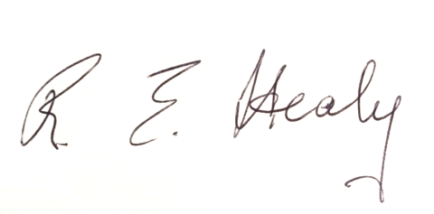

Dr Roisin Healy, Spokesperson, C4KH, Mobile 086 6020601,
Email address - connollyforkidshospital@gmail.com

